Public Class Juego

Private Sub btnAdelante_Click(ByVal sender As System.Object, ByVal e As System.EventArgs) Handles btnAdelante.Click

tmrAdelante.Start()

tmrAbajo.Start()

tmrArriba.Stop()

tmrAtras.Stop()

End Sub

Private Sub tmrAdelante_Tick(ByVal sender As System.Object, ByVal e As System.EventArgs) Handles tmrAdelante.Tick

If pctImagenGif.Location.X >= 713 Then

tmrAdelante.Stop()

Else

pctImagenGif.Left = pctImagenGif.Location.X + 2

End If

End Sub

Private Sub btnAtras_Click(ByVal sender As System.Object, ByVal e As System.EventArgs) Handles btnAtras.Click

tmrAtras.Start()

tmrAdelante.Stop()

tmrArriba.Stop()

tmrAbajo.Stop()

End Sub

Private Sub tmrAtras_Tick(ByVal sender As System.Object, ByVal e As System.EventArgs) Handles tmrAtras.Tick

If pctImagenGif.Location.X = 0 Then

tmrAtras.Stop()

Else

pctImagenGif.Left = pctImagenGif.Location.X - 2

End If

End Sub

Private Sub btnArriba_Click(ByVal sender As System.Object, ByVal e As System.EventArgs) Handles btnArriba.Click

tmrArriba.Start()

tmrAbajo.Stop()

tmrAdelante.Stop()

tmrAtras.Stop()

End Sub

Private Sub tmrArriba_Tick(ByVal sender As System.Object, ByVal e As System.EventArgs) Handles tmrArriba.Tick

If pctImagenGif.Location.Y = 144 Then

tmrArriba.Stop()

Else

pctImagenGif.Top = pctImagenGif.Location.Y - 2

End If

End Sub

Private Sub btnAbajo_Click(ByVal sender As System.Object, ByVal e As System.EventArgs) Handles btnAbajo.Click

tmrAbajo.Start()

tmrArriba.Stop()

tmrAdelante.Stop()

tmrAtras.Stop()

End Sub

Private Sub tmrAbajo_Tick(ByVal sender As System.Object, ByVal e As System.EventArgs) Handles tmrAbajo.Tick

If pctImagenGif.Location.Y = 470 Then

tmrArriba.Stop()

Else

pctImagenGif.Top = pctImagenGif.Location.Y + 2

End If

End Sub

Private Sub btnDetente_Click(ByVal sender As System.Object, ByVal e As System.EventArgs) Handles btnDetente.Click

tmrAdelante.Stop()

tmrAtras.Stop()

tmrArriba.Stop()

tmrAbajo.Stop()

End Sub

Private Sub pctArriba_Click(ByVal sender As System.Object, ByVal e As System.EventArgs) Handles pctArriba.Click

tmrArriba.Start()

tmrAbajo.Stop()

tmrAdelante.Stop()

tmrAtras.Stop()

End Sub

Private Sub pctAbajo_Click(ByVal sender As System.Object, ByVal e As System.EventArgs) Handles pctAbajo.Click

tmrAbajo.Start()

tmrArriba.Stop()

tmrAdelante.Stop()

tmrAtras.Stop()

End Sub

Private Sub pctAdelante_Click(ByVal sender As System.Object, ByVal e As System.EventArgs) Handles pctAdelante.Click

tmrAdelante.Start()

tmrAbajo.Stop()

tmrArriba.Stop()

tmrAtras.Stop()

End Sub

Private Sub pctAtras_Click(ByVal sender As System.Object, ByVal e As System.EventArgs) Handles pctAtras.Click

tmrAtras.Start()

tmrAdelante.Stop()

tmrArriba.Stop()

tmrAbajo.Stop()

End Sub

Private Sub pctDetente_Click(ByVal sender As System.Object, ByVal e As System.EventArgs) Handles pctDetente.Click

tmrAdelante.Stop()

tmrAtras.Stop()

tmrArriba.Stop()

tmrAbajo.Stop()

tmrTurbo.Stop()

End Sub

Private Sub pctTurbo_Click(ByVal sender As System.Object, ByVal e As System.EventArgs) Handles pctTurbo.Click

tmrTurbo.Start()

tmrAdelante.Start()

tmrAtras.Stop()

tmrArriba.Stop()

tmrAbajo.Stop()

End Sub

Private Sub tmrTurbo_Tick(ByVal sender As System.Object, ByVal e As System.EventArgs) Handles tmrTurbo.Tick

tmrAdelante.Stop()

If pctImagenGif.Location.X >= 713 Then

tmrTurbo.Stop()

Else

pctImagenGif.Left = pctImagenGif.Location.X + 8

End If

End Sub

Private Sub Juego_Load(ByVal sender As System.Object, ByVal e As System.EventArgs) Handles MyBase.Load

pctImagenGif.Visible = False

pctArriba.Visible = False

pctAbajo.Visible = False

pctAdelante.Visible = False

pctAtras.Visible = False

pctDetente.Visible = False

pctTurbo.Visible = False

End Sub

Private Sub btnJugar_Click(ByVal sender As System.Object, ByVal e As System.EventArgs) Handles btnJugar.Click

pctImagenGif.Visible = True

pctArriba.Visible = True

pctAbajo.Visible = True

pctAdelante.Visible = True

pctAtras.Visible = True

pctDetente.Visible = True

pctTurbo.Visible = True

btnJugar.Visible = False

My.Computer.Audio.Play(Application.StartupPath + "\Imagenes\Simpsons.WAV", AudioPlayMode.BackgroundLoop)

End Sub

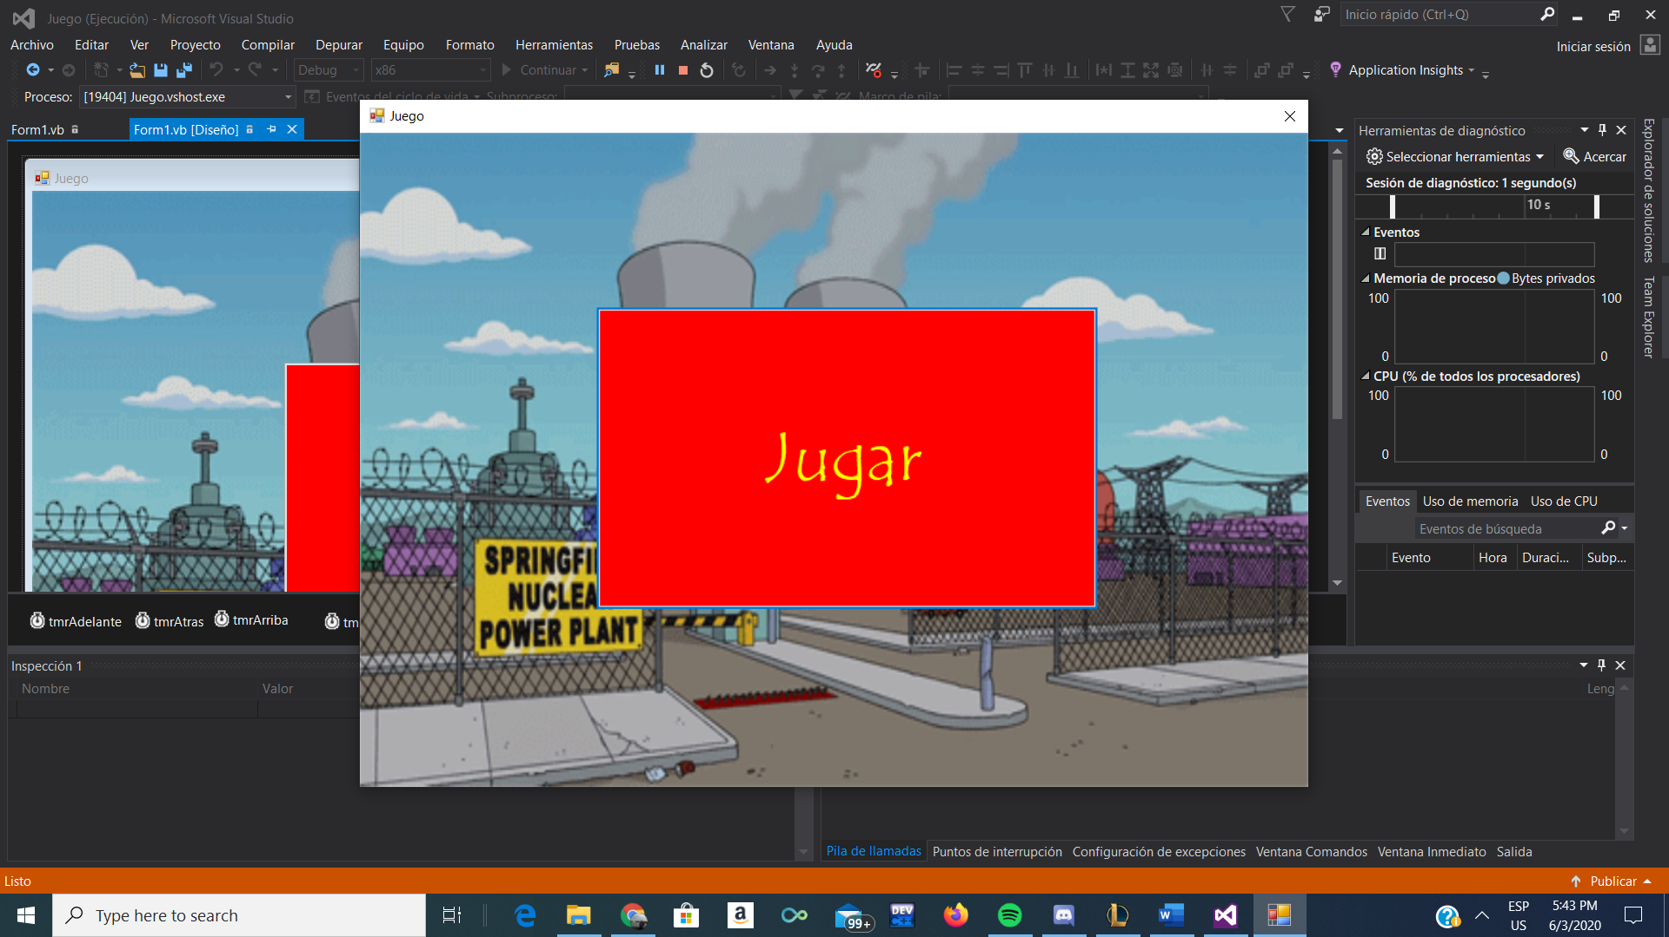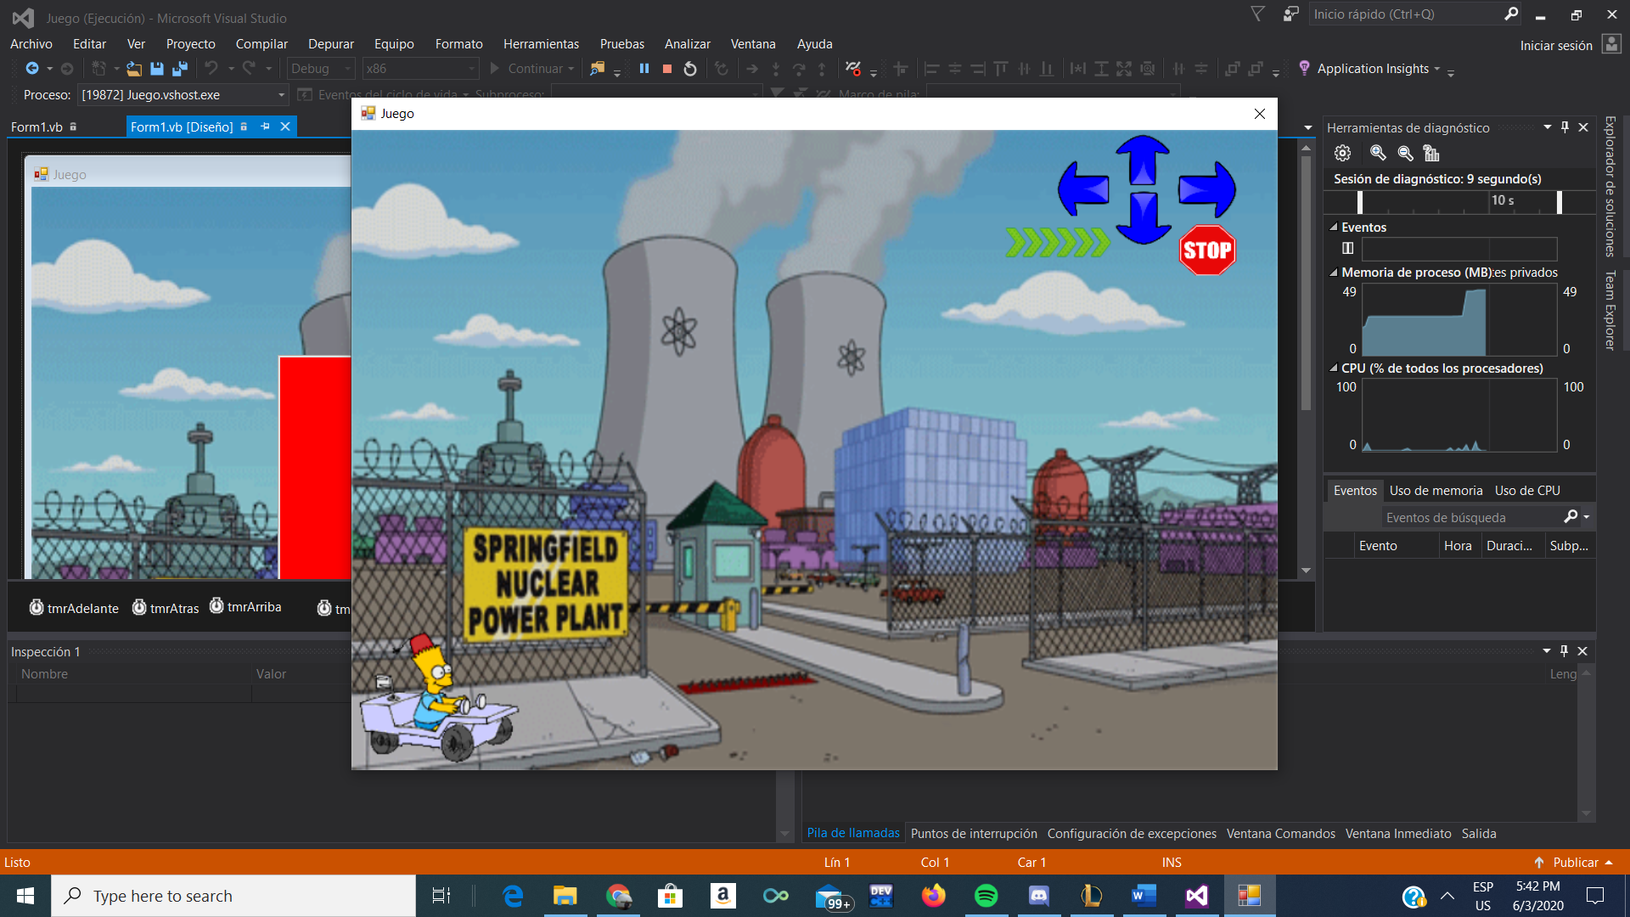End Class